Problem 1: Requirements Elicitation & Prioritization in a College Attendance System

1. List of Four Well-Defined Requirements
- Teachers should be able to enter the student's Roll Number and Name to mark attendance.
- Teachers should be able to mark each student as Present or Absent.
- The system should automatically update the Present and Absent counts and display the attendance records.
- The system should provide a simple, user-friendly interface that is easy to use and cost-effective.

2. MoSCoW Prioritization Table
Requirement | Priority | Reason
Student attendance marking (Present/Absent) | Must Have | Core functionality of the attendance system.
Attendance record table | Should Have | Helps teachers view attendance records.
Dashboard showing Present and Absent counts | Could Have | Improves monitoring and reporting.
Student attendance history and analytics | Won't Have (Current Release) | Can be implemented in future versions.

3. Kano Model Classification
Feature | Kano Category
Marking student attendance | Basic Requirement
Attendance dashboard (Present/Absent counts) | Performance Requirement
Attendance notifications and reminders | Excitement Requirement

4. Stakeholder Conflict and Resolution

Conflict
Teachers want an easy and accurate way to mark attendance, students expect attendance records to be updated correctly, while college management requires a simple and low-cost attendance management system that can be implemented quickly.

Resolution Plan
- Gather requirements from teachers, students, and management through meetings.
- Prioritize the core attendance marking feature using the MoSCoW technique.
- Develop the attendance management system with roll number, student name, and Present/Absent status in the first phase.
- Add advanced features such as attendance reports, notifications, and biometric integration in future phases.
Block Diagram
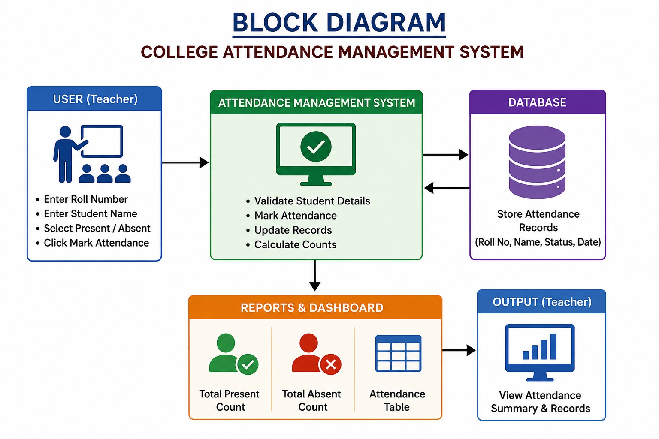

Conclusion
The College Attendance Management System provides a simple and efficient way for teachers to record student attendance using roll numbers, names, and Present/Absent status. The system automatically updates attendance records and displays a dashboard showing the total number of present and absent students. Advanced features such as biometric authentication, attendance reports, and mobile access can be added in future versions without affecting the core functionality of the system.

